**RESOURCES FOR THE SECOND PHASE AND THIRD PHASE OF THE BLW-DALLAS WEBSITE**

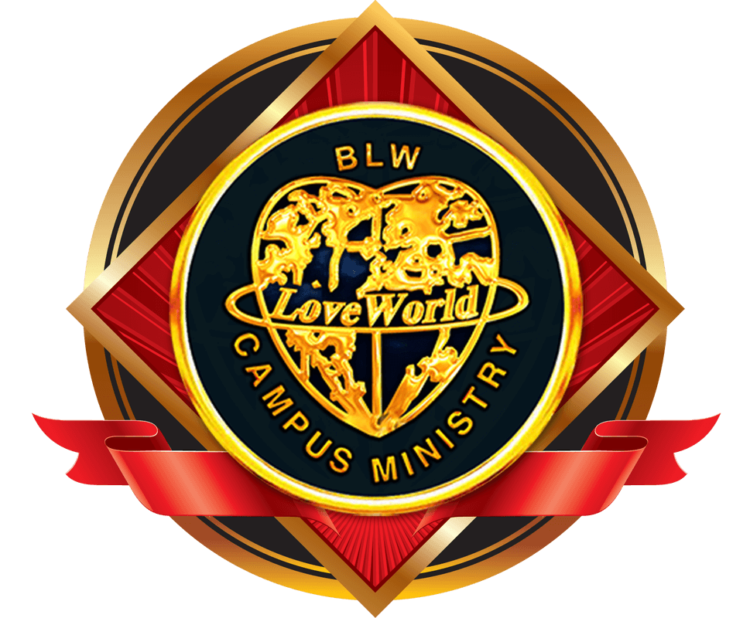

**About:**

Believers’ LoveWorld Campus Ministry is the youth arm of Believers’ LoveWorld; a unique and dynamic ministry called by God to play a chief role in the end time move of the Spirit. Our Vision is to carry God’s divine presence to all the people of the world, demonstrating to them the character of the Spirit.

Rev Chris Oyakhilome Ph.D has a passion to see lives transformed by the power of God, and millions of young people across the globe have been affected by his ministry. Many of whom have dedicated their lives to reaching other young people in the world.

**History:**

Through an anointed ministry spanning over 25 years, Pastor, teacher, healing minister, television host and bestselling author Pastor Chris Oyakhilome (PhD) has helped millions experience a victorious and purposeful life in God’s word. He is the author of the bestseller Rhapsody of Realities, the number one daily devotional around the world. Several millions of copies of the best-selling daily devotional and Bible-study guide have been distributed in over 242 countries in over 402 languages of the world including Afrikaans, Arabic, Cantonese, Croatian, Dutch, English, Finnish, French, German, Hindi, Icelandic, Italian, Mandarin, Myanmar, Portuguese, Russian, Spanish, Swahili…and still counting! New languages are also added regularly, thereby making the devotional accessible to many more in different parts of the globe, thus bringing the richness of God’s Word into their lives. Little wonder the devotional, oftentimes, is referred to as the, “Messenger Angel”.

Presiding over an ever-widening network of Christ Embassy Churches and campus fellowships on all five continents, Pastor Chris also pastors one of the largest congregations in Africa. He holds massive teaching and healing crusades like the Higher Life conference and Night of Bliss with crowds of over 3.5 million in a single night’s event. Pastor Chris in the year 2003, pioneered the first 24-hour Christian Network from Africa to the rest of the world, and this has given rise to three satellite stations, the LoveWorld TV in the UK, LoveWorld SAT in South-Africa and LoveWorld PLUS in Nigeria and still counting. Through this medium, millions of people have been reached with the beautiful message of salvation and many lives have been transformed. These stations are also available on the mobile platform.  
 Pastor Chris is also the host of “Atmosphere for Miracles”, a program airing on major television networks in the United States of America, the United Kingdom, Asia, Europe and around the world, which brings God’s divine presence right into the homes of millions around the world. With a burning desire to bring God’s word to all men in simplicity and with the power of the spirit, the man of God, Pastor Chris Oyakhilome (PhD), established the International School Of Ministry, specifically to train and equip ministers of the gospel of Christ, building in them the realities of God’s word and empowering them to carry the message of eternal life in Christ Jesus to their world, with great demonstration of the miraculous power of God.  
Pastor Chris also pioneered the establishment of the Inner City Mission of Christ Embassy, a ministry to children living in the inner cities of our world, to give them a hope and a future.

In 2016, it was indeed our year of spreading as the BLW Campus Ministry Missions spread into every man’s world with the message of our gospel and the vision of our Man of God; to take God’s divine presence to the nations of the world, demonstrating the character of the Spirit.

The year of Spreading witnessed the pioneering of BLW Campus fellowships in 118 tertiary institutions in 16 countries such as Mauritius, Indian, Rwanda, Ethiopia, Gabon, Cote D’ivoire, Japan, Brazil, DRC Congo, Sierra Leone etc, recording a total cumulative attendance of 1,752 in every service.

At the end of 2016, over a thousand (1,000) BLW Campus Fellowships have been pioneered so far in 41 countries of the world where the BLW Campus Fellowships in tertiary institutions is strongly felt.

In 2017, we are set to triple that and flourish significantly in three thousand (3,000) tertiary institutions across 150 nations of the world. from January to the period of writing, BLW Campus fellowship have already been pioneered in Hungary, Philippines, Germany, China, Fiji, Caledonia, Austraila, Austria, Solomon Island, Libya, Venezuela, South Korea, France, Gabon, Poland, Guinea Bissau, Sweden, Spain, Russia and still counting.

With the creation of two new zones; BLW Zimbabwe Zone and BLW Botswana Zone, the reality of 3,000 fellowships is certain as more and more vibrant and passionate leaders are raised for the furtherance of the gospel and establishment of the kingdom of God in their sphere of contact through the BLW Missions.

**Our Vision:**

*To take the divine presence of God to the people of the world and to demonstrate the character of the Holy Spirit.*

The Believers’ Loveworld Campus Ministry is the youth arm of the Believers’ Loveworld Nation (Christ Embassy). It is a unique and dynamic ministry called by God to play a chief role in the end time move of the Spirit, with a vision to take God’s divine presence to the young people in every Nation of the World; demonstrating in them, the character of the spirit.

This Ministry is inspired by the President and founder of the Believer’s LoveWorld Inc. Pastor Chris Oyakhilome, who also is the author of the world’s No.1 most read daily devotional (Rhapsody of Realities), along with numerous bestselling and life transforming Christian books. He is also the host of several impactful Christian Television Programs aired in several countries all around the globe, including the well-known “Atmosphere for Miracles” TV program. He has caught the vision and passion for transforming the Nations of the world with the presence and power of God, and has greatly succeeded in carrying out this divine vision and mission of bringing the reality and manifestations of the divine life to countless around the world. As a result of this selfless commitment to the gospel of Christ, millions of young people across the globe have been greatly impacted by the Believers’ Loveworld ministry through the Campus Ministry. Many of whom have dedicated their lives to reaching out to other young people in their worlds.

With an ever-widening network of BLW fellowships across the world, the BLW Campus Ministry is gaining increasing influence, in higher institutions and colleges spread across Europe, Australia, North America, South East Asia, the Arab Nations, and in the Western, Eastern and Southern regions of the African Continent.

**Our Mission**

To raise generations of men and women who will come into their inheritance to fulfill God’s dream.

**Our Purpose**

To bring them into their inheritance

**Mandate:**

Our mandate is to have Believers’ Love World Campus Ministry registered and active in several schools and on various campuses in the Dallas metroplex, and to infiltrate the school systems with the Rhapsodies of Realities and ministry messages.

**The Dallas Metroplex**

The Dallas Metroplex is one of the fastest growing metropolis in the United States. It consists of 13 counties and includes major cities like Dallas, Fort-Worth, Plano, Irving, and Arlington. In terms of its growing population and popularity, the Dallas Metroplex is at a position for attention for the expansion of God’s Kingdom and the Believers’ Love World Campus Ministry.

The Dallas Metroplex consists of over twenty colleges and universities, and strategies are currently in place to have Believers’ Love World Campus Ministry registered and active in each school. Listed below are the targeted schools in the Dallas Metroplex for this purpose.

|  |  |  |
| --- | --- | --- |
| UNIVERSITIES/COLLEGES | TYPE | LOCATIONS |
| Arlington Baptist College | Private College | Arlington |
| Baylor University | Private University | Waco |
| Brookhaven College | Community College | Farmers Branch |
| Cedar Valley College | Community College | Lancaster |
| Collin College | Community College | Plano / Frisco / McKinney |
| Criswell College | Private College | Dallas |
| Dallas Baptist University | Private University | Dallas |
| Eastfield College | Community College | Mesquite |
| El Centro College | Community College | Dallas |
| Mountain View College | Community College | Dallas |
| North Lake College | Community College | Irving |
| Northwood University | Private University | Cedar Hill |
| Paul Quinn College | Private College | Dallas |
| Richland College | Community College | Dallas |
| Southern Methodist University | Private University | Dallas |
| Traleton State University | Public University | Stephenville / Fort-Wort/ Waco |
| Tarrant County College | Community College | Tarrant |
| Texas A&M University - Commerce | Public University | Commerce |
| Texas Christian University | Private University | Fort Worth |
| Texas Wesleyan University | Private University | Fort Wort |
| Texas Woman’s University | Public University | Denton / Dallas |
| University of Dallas | Private University | Irving |
| University of North Texas | Public University | Denton / Dallas |
| University of North Texas – Health Science Center | Public University | Fort Worth |
| University of Texas – Arlington | Public University | Arlington |
| University of Texas – Dallas | Public University | Richardson |
| University of Texas – Southwestern Medical Center | Public University | Dallas |
| Wade College | Private College | Dallas |
| Weatherford College | Public University | Weatherford |

**Contact Information:**

|  |  |  |
| --- | --- | --- |
| Pastor Henry Unegbu  BLWCM  Dallas Metroplex Pastor  512-287-9170 | Jennifer Debebs  BLWCM  Dallas Metroplex Secretary  214-909-0148 | Email:  blwdallastxgroup@gmail.com |

|  |  |  |
| --- | --- | --- |
| UNIVERSITIES/ COLLEGES | CO-ORDINATOR | CONTACT INFORMATION |
| Richland College | Rio Ahanene | 469-831-4087 |
| Collin College | Jennifer Debebs | 214-909-0148 |
| University of Texas, Dallas | Rio Ahanene | 469-831-4087 |
| University of North Texas, Denton | Michelle Wiggle | 214-771-1720 |
| Texas Women University, Denton | Diana Iduozee | 972-374-6176 |
| Southern Methodist University | Clinton Iduozee | 214-296-7489 |
| North Lake College | Cara | 469-260-7901 |
| Baylor University | Godfrey Evbuomwanm | 832-270-6583 |
| University of North Texas, (Health Science Center) | Chinelo | 713-367-2903 |